Create Your Individualized
Term Long Calendar

STEP 1: CREATE A BLANK TEMPLATE OF YOUR TERM-LONG CALENDAR

- Create a term-long monthly calendar. This calendar should start with the month in which the first day of instruction begins and include all months through the last day of final exams. Make sure the calendar is organized by week and includes all seven weekdays. For those who would like to make there own calendar, I’ve provided a template for you.

STEP 2: SCHEDULE IMPORTNANT REGISTRATION DATES

- Google search “Academic Calendar” for your institution.

- Find a master academic calendar for the upcoming academic term.

- Fill in important registration dates on your term-long calendar including:
☐ First day of instruction
☐ Deadline to drop classes for a full refund
☐ Deadline to withdrawal (late drop) from a class
☐ All academic holidays
☐ Last day of instruction
☐ First and last days of final exams
☐ Any other important registration dates

STEP 3: SCHEDULE FINAL EXAMS FOR YOUR CLASSES

- Google search “Final Exam Schedule” for the upcoming term at your institution

- Fill in the dates, times and locations of your final exams for the upcoming academic term.

STEP 4: SCHEDULE ALL EXAMS, PAPERS, AND IMPORTANT DUE DATES FOR YOUR CLASSES

- For each class that you are currently enrolled in, find your course syllabus or the calendar of due dates for this course.

- Fill in the dates and times for all exams, quizzes or assessments. This include
☐ In-class exams (i.e. midterm exams)
☐ In-class quizzes
☐ Take home exams due-dates
☐ Any other assessment date you think you need to remember for your classes

- Fill in the due-dates for every important assignment from each class
☐ Term paper due dates
☐ Term project due dates
☐ Homework assignment due dates
☐ Any other due date you think you need to remember for your classes

STEP 5: SCHEDULE IMPORTANT PERSONAL DATES AND ACTIVITIES

- Schedule important personal dates that you know will occur in the upcoming academic quarter. These include:

☐ Birthday’s of family and close friend (include your birthday)
☐ Family Holidays, Religious Holidays, or Religious events
☐ Weddings or Graduation ceremonies
☐ Extracurricular activates (student athletics, club trips, etc.)
☐ Travel, special local events, and weekend trips
☐ Medical appointments

Plan a few rejuvenating activities into your term calendar. These will help balance your academic life. This might include a day trip to your favorite local city, a professional massage, a trip to the movies, time with family or friends, or any other special activity that makes you happy. Plan your personal activities to support your best effort in your classes. BE CAREFUL to schedule these activities at appropriate times during the quarter. Scheduling a fun weekend with family immediately before Monday midterm exam is probably a bad idea. However, scheduling a trip to the movies in the afternoon immediately after that exam might provide a well-earned 3-hour break.

WARNING: Avoid long, intense personal activities during your academic term (i.e. international travel, week-long family vacations, interviewing for a new job, etc.). It is best to schedule these types of activities during Summer Break, Winter Break, or Spring Break.

- Contact your family and close friends to find out if they have anything planned that you are expected to attend between the first day of instruction and the last day of final exams for the upcoming term. If so, mark this event appropriately.

STEP 6: REVIEW YOUR EXAM SCHEDULE

- Look back at you're the calendar you created in Steps 1 – 5 above.

- If you have a time conflict with any of your regularly scheduled exams:
☐ Cancel the activity that conflicts with this exam.
☐ Enroll in another section with a scheduled exam time that works.
☐ Drop this course and re-enroll during a quarter that will work
☐ Plan to ask your professor to reschedule your final exam

Be very careful about asking a professor to reschedule your exam. Most professors will state their policy about rescheduling exams on the class syllabus. Make sure to read the syllabus carefully if you are in this situation. Also, be considerate of your instructors: try this option only if you really can’t find any other alternatives.

- If you have any activities planned on the weekend before to final exams:
☐ Reschedule those activities to another date after finals have finished.
☐ Plan lots of extra study time during the two weeks prior to final exams.

- If you have plans immediately after any of your final exams:
☐ Reschedule these activities.
☐ Be ready to sacrifice your ability to stay extra time after the final if available.

Do not plan activities for 3-6 hours after any scheduled final exam. I suggest this for two reasons. First, sometimes instructors will announce during a final that there is extra time to finish your exam. If you’ve scheduled yourself for activities immediately following finals, you will likely lose out if this happens. Also, the process of preparing for and taking a final can be very stressful. By planning to have free time after each final exam, you guarantee time to get food, take a nap and recover.

STEP 7: UNDERSTAND YOUR TIME CONFLICTS

TABLE 3.1: list of ABsenCes FOR TERm
DATE OF ABSENCE | DAY OF WEEK | CLASSES AFFECTED
- Review your Term-Long Academic Calendar from Conquering College Video 2.

- Determine all dates that you have a time conflict with an in-class meeting. Track these dates on Table 3.1 below.

STEP 2: ADDITIONAL INFORMATION

Below are important dates for winter quarter. You can find these dates using the following steps:

Step 1: Web search the phrase “Foothill College Academic Calendar Winter 2022”
Step 2: Navigate to the link: https://www.foothill.edu/calendar/index.html
Step 3: Find the link Winter Registration Dates & Deadlines

Those steps lead to the list of dates seen below:

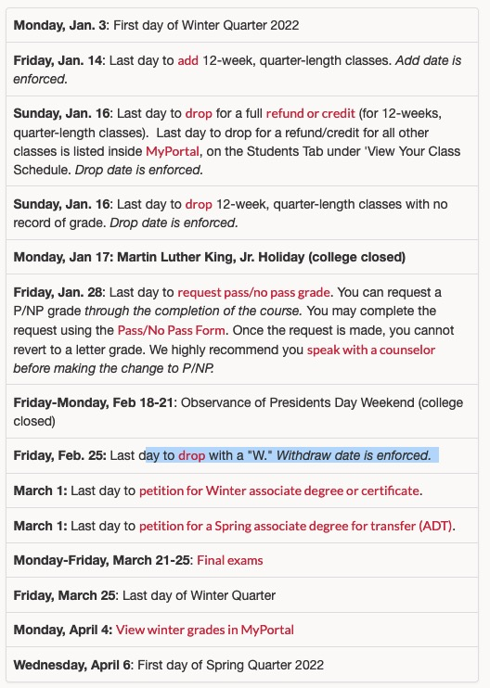

In addition to important registration dates for winter quarter, you may want to sign up for classes at Foothill during spring quarter 2022. To find important spring 2022 registration dates, use the following steps:

Step 4: Web search the phrase “Foothill College Academic Calendar spring 2022”
Step 5: Navigate to the link: https://www.foothill.edu/calendar/index.html
Step 6: Find the link Spring Registration Dates & Deadlines

Those steps lead to the list of dates seen below:
