Math 48B, Lesson 13: The Natural Exponent Function

In Math 48B Lessons 11, 12, and 13, we study exponential functions:

$$y=b^{x}$$

To begin our exploration, let’s recall the rules of powers/exponents.

1. WHAT ARE RULES OF POWERS/EXPONENTS?

Powers vs exponents: $y=x^{n}$ $y=b^{x}$

Product Rule: $b^{n}∙b^{m}$

Quotient Rule: $\frac{ b^{n} }{b^{m}}$

Zero Power: $1=\frac{ b }{b}=\frac{ b^{1} }{b^{1}}$

Negative Powers: $\frac{ 1 }{b^{n}}$

Power to a Power: ${\left(b^{n}\right)}^{p}$

2. HOW DO COMMERICAL BANKS MAKE MONEY?

There are two types of banks in our economy:

- Commercial banks take deposits, provide checking services, provide savings accounts to individuals and small businesses, and provide business, personal, and mortgage loans. This is the role that most banks in your local town play (think Bank of America, your local credit union, etc).

- Investment banks play provide financial services to help large corporations set up Initial Public Offerings (IPO), get debt financing, facilitate stock trading, and deal with large-scale financial services.

When speaking about exponential growth and the natural exponent function, it’s useful to construct a simple model for commercial banking.

Below is a visual diagram to represent how commercial banks make money.
Let’s do a simple thought experiment. Suppose that a local bank serves 10,000 customers, each of whom has $110,000 in savings. Let’s analyze how that bank makes money providing services to it’s clients.
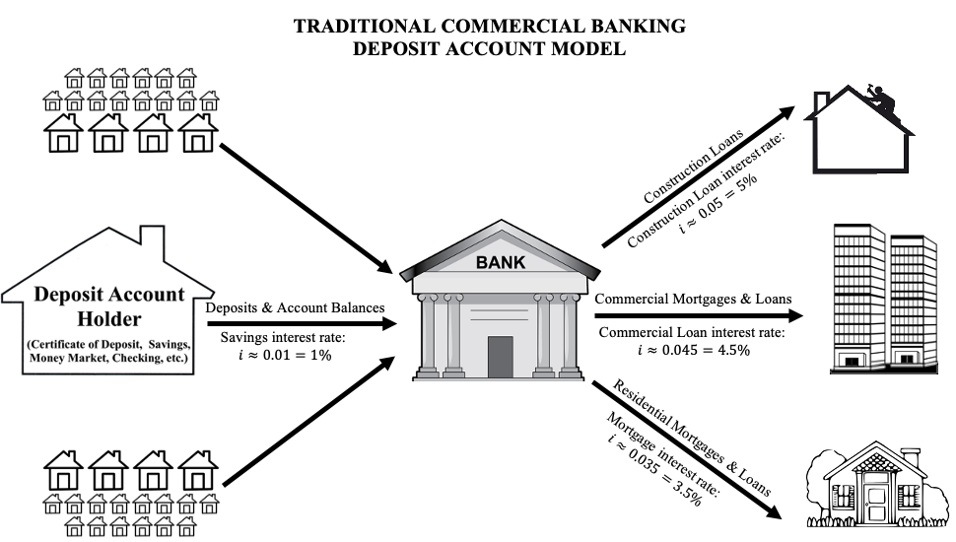

3. SOME OF MY FAVORITE FINANCIAL HABITS
Below are some of my favorite monthly financial habits:
- Get educated

Schools do a terrible job of teaching financial literacy and financial planning. I recognized that as a younger person. Over the years, I’ve spent a ton of time teaching myself about finances. I read financial books and seek out financial information about topics that interest me (savings habits, how to pay off debt, how to manage personal finances, how to save for a home, how to build my credit score, etc). I look at this as one of the ways that I protect my family.

- Invest in family and memories (and live simple)

There are a few things that I say yes to spending on. These including family, shared memories, education, and preventative health activities (nutrition, running races, zumba classes, gym equipment, etc) and advocacy organizations (public radio, BLM, etc). I buy lots of books, pay for classes and activities, pay for vacations, etc. On the other hand, I could care less about fancy new cars, expensive items, extravagant vacations, and prestige. I put my money into my loved ones and live a relatively simple life outside of those core relationships.

- Pay myself first

I hold multiple accounts with a multiple banks. This includes a checking account and multiple savings accounts (long-term savings, college savings for each son, vacation savings account,car savings account, retirement accounts, etc). The first thing that I do when I get a paycheck is put money into my various savings account. My goal is always to put at least 10% of my income into savings. Before I was married, I used to put 40% - 50% into savings every month. I would then plan all my expenditures out of the money left over.

- Build an emergency nest egg in checking and savings

I like to keep a $2000 minimum cash balance in my checking account at all time. I also try to keep enough cash in savings to pay for 12 months of my life (assuming I had no job and no income). I track my expenses so I know how much I spend each month. I also spent many years saving up this amount of money.

- Build credit by pay off credit cards in full at the end of each month.

I strategically build credit by reading about how to build good credit and then getting loans or credit cards to work towards that aim. I set a goal for myself to pay my credit card balance down to zero at the end of each payment cycle. In other words, I set a goal to carry zero balance on my cards every month. I use the cards to get rewards. For big purchases I desire, I try to save in advance as much as possible (for car and home purchases, that wasn’t possible).

- Snowball debt payments until I have zero debt.
Over the years, I’ve had to take out debt to finance some of the costs of my life including school loans and car loans. I use the snowball method to get those payments down to zero much quicker than expected and then funnel those payments back into savings.

4. SOME BASIC FINANCIAL MATH FORMULAS?

Below is a table of a collection of basic financial math formulas. We’re going to explore these together as a team.

Formula name | Equation | Symbol name
Simple interest  formula | $${P_{n}=P}_{0}∙\left(1+n∙i\right)$$ | $P_{0}=Initial principal$  $n=Number of interest periods$  $$P_{n}=Future value at end of nth period$$  $$m=Number of interest periods per year$$  $$i_{m}=nominal interest rate (as decimal)$$
Interest rate per period | $$i=\frac{i_{m}}{m}$$ | $$m=Number of interest periods per year$$  $$i_{m}=nominal interest rate (as decimal)$$
Compound interest formula | $${P_{n}=P}_{0}∙{\left(1+i\right)}^{n}$$ | $P_{0}=Initial principal$  $n=Number of interest periods$  $$P_{n}=Future value at end of nth period$$  $$m=Number of interest periods per year$$  $$i_{m}=nominal interest rate (as decimal)$$
Principle in 1st period | $${P_{1}=P}_{0}∙\left(1+i\right)$$ | $P_{0}=Initial principal$  $$P_{1}=Future value at end of 1st period$$  $$i=Interest rate per period$$
Principle in k^{th} period | $${P_{k+1}=P}_{k}∙\left(1+i\right)$$ | $P_{k}=Principal after k periods$  $$P_{k+1}=Future value at end of (k+1)st period$$  $$i=Interest rate per period$$
Compound interest theorem | $${P_{n}=P}_{0}∙{\left(1+i\right)}^{n}$$ | $P_{0}=Initial principal$  $n=Number of interest periods$  $$P_{n}=Future value at end of nth period$$  $$i=Interest rate per period$$

5. WHAT IS SIMPLE INTEREST?

Below is a table that describes how simple interest is calculated.

Simple Interest: Deposit Account Balance
Spreadsheet Format
Interest Period | Period’s Beginning  Principle  (Starting Account Balance) | Period’s Interest  Charge | Period’s Ending  Principal  (Ending Account Balance)
$$n=0$$ | $$P_{0}$$ | $${i∙P}_{0}$$ | $$P_{1}=P_{0}+ {i∙P}_{0}$$
$$n=1$$ | $$P_{1}$$ | $${i∙P}_{0}$$ | $$P_{2}=P_{1}+ {i∙P}_{0}$$
$$n=2$$ | $$P_{2}$$ | $${i∙P}_{0}$$ | $$P_{3}=P_{2}+ {i∙P}_{0}$$
$$n=3$$ | $$P_{3}$$ | $${i∙P}_{0}$$ | $$P_{4}=P_{3}+ {i∙P}_{0}$$
$$n=4$$ | $$P_{4}$$ | $${i∙P}_{0}$$ | $$P_{5}=P_{4}+ {i∙P}_{0}$$

Let’s analyze a simple interest construction loan program from the county of Alameda. In this case, the borrower took out an $88,000 loan to remodel a home that was falling apart. Let’s analyze that loan and figure out how it worked.

6. WHAT IS COMPOUND INTEREST?

Consider the following Compound Interest formula:

$${P_{n}=P}_{0}∙{\left(1+\frac{i_{m}}{m}\right)}^{n}$$

In this formula, we have the following values for each of the variables:

$P_{0}=Initial principal$
$n=Number of interest periods paid$
$$P_{n}=Future value at end of nth period$$
$$m=Number of interest periods per year$$
$$i_{m}=nominal interest rate (as decimal)$$

Let’s explore this formula as a team.

Below is a table that describes how compound interest is calculated.

Compound Interest: Deposit Account Balance
Spreadsheet Format
Interest Period | Period’s Beginning  Principle  (Starting Account Balance) | Period’s Interest  Charge | Period’s Ending  Principal  (Ending Account Balance)
$$n=0$$ | $$P_{0}$$ | $${i∙P}_{0}$$ | $$P_{1}=P_{0}+ {i∙P}_{0}$$
$$n=1$$ | $$P_{1}$$ | $${i∙P}_{1}$$ | $$P_{2}=P_{1}+ {i∙P}_{1}$$
$$n=2$$ | $$P_{2}$$ | $${i∙P}_{2}$$ | $$P_{3}=P_{2}+ {i∙P}_{2}$$
$$n=3$$ | $$P_{3}$$ | $${i∙P}_{3}$$ | $$P_{4}=P_{3}+ {i∙P}_{3}$$
$$n=4$$ | $$P_{4}$$ | $${i∙P}_{4}$$ | $$P_{5}=P_{4}+ {i∙P}_{4}$$

Let’s analyze the interest paid on a savings account: assume we put $10,000 in a savings account at the start of the year and that we are paid 2% interest on our savings. For this exploration, let’s assume we add no money to the account after our initial deposit. Let’s analyze that loan and figure out how it works.

7. WHAT IS THE NATURAL EXPONENT?
Our compound interest calculations from the last example are related to a classic problem in mathematics. Suppose we have an account that starts with $1.00 and pays 100% interest. What happens to that account as the number of times we compound that interest becomes more and more frequent?
$$m$$ | $${\left(1+\frac{1}{m}\right)}^{m}$$
$$1$$
$$2$$
$$4$$
$$12$$
$$365$$

$$m$$ | $${\left(1+\frac{1}{m}\right)}^{m}$$
$$1000$$
$$10000$$
$$100,000$$
$$1,000,000$$

7B. We say that the natural exponent is given as

$$e=\lim_{m→∞}{{\left(1+\frac{1}{m}\right)}^{m}}≈2.71828182845904523536…$$

This leads to the natural exponent function

$$f(x)=e^{x}$$
Let’s use Desmos.com to graph this function and compare that graph to the functions $2^{x}$ and $3^{x}$.

8. GRAPH THE NATURAL EXPONENT FUNCTION

Let’s use Desmos.com to sketch a graph of the following functions:

$g\left(x\right)=e^{-x}$ and $h\left(x\right)=3e^{x/2}$

For each function, let’s identify the domain and range, as well as the asymptote(s).

